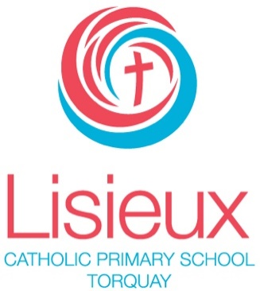
Contents
LISIEUX CATHOLIC PRIMARY SCHOOL
TORQUAY NORTH
REGISTERED SCHOOL NUMBER: 1406

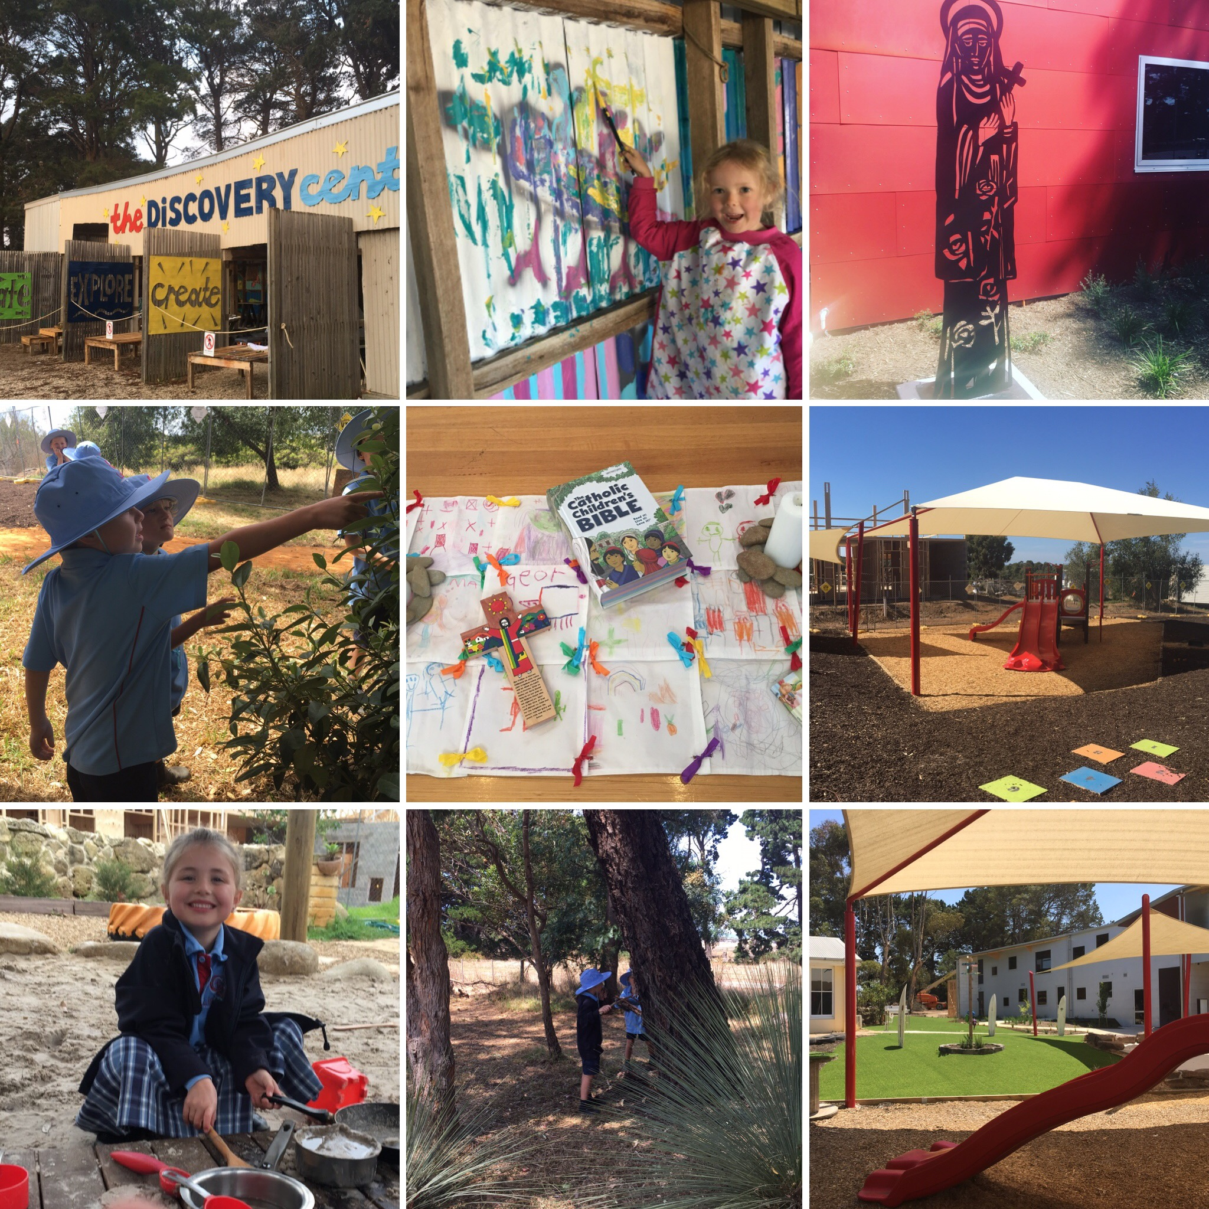

2018
ANNUAL
REPORT
TO THE SCHOOL
COMMUNITY
Contact Details 2
Minimum Standards Attestation 2
Our School Vision 3
School Overview 4
Principal’s Report 5
Education in Faith 6
Learning & Teaching 8
Student Wellbeing 11
Child Safe Standards 17
Leadership & Management 18
School Community 22

Contact Details
ADDRESS | 90 SOUTH BEACH ROAD, TORQUAY NORTH, 3228
PRINCIPAL | DR SUSAN RYAN
PARISH PRIEST | FATHER LINH TRAN
SCHOOL BOARD CHAIR | MR MICHAEL TIMMS
TELEPHONE | (03) 9089 6614
EMAIL | principal@lisieux.catholic.edu.au
WEBSITE | https://lisieux.catholic.edu.au
E NUMBER | 1406

Minimum Standards Attestation
I, SUSAN RYAN attest that LISIEUX CATHOLIC PRIMARY SCHOOL is compliant with:
- All of the requirements for the minimum standards and other requirements for the registration of schools as specified in the Education and Training Reform Act 2006 (Vic) and the Education and Training Reform Regulations 2017 (Vic), except where the school has been granted an exemption from any of these requirements by the VRQA
- Australian Government accountability requirements related to the 2018 school year under the Australian Education Act 2013 (Cth) and the Australian Education Regulations 2013 (Cth)
APRIL 1, 2019

Our School Vision

LISIEUX School vision
In a vibrant school community, and with Christ as our guiding light, we strive to:
- Nurture the development of the whole person as unique individuals made in God’s image
- Foster a love of life, learning and God’s creation
- Pursue fullness of life for all.

LISIEUX School mission
We strive to achieve our vision in the following ways:
- Enabling gospel values to permeate all facets of school life, encouraging each child’s relationship with God
- Providing diverse and engaging learning experiences to meet the needs and learning styles of each student
- Building a culture based on the premise that every child can learn
- Encouraging each student to recognise and nourish their gifts and talents and those of others.

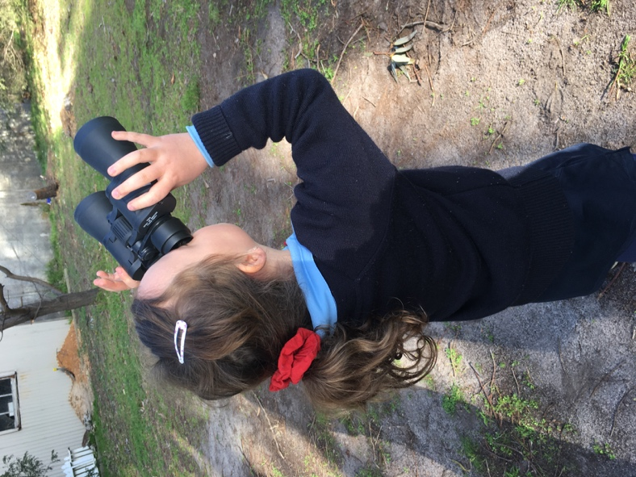
School Overview
Lisieux Catholic Primary School was founded in 2018 in South Beach Road, Torquay. In 2018, it operated as a vibrant P-Year 3 co-educational learning community from the site of a former home at the location, while Stage 1 building works continued. With a small cohort of students and a dedicated staff team, a strong community foundation was laid.
Situated in Torquay, Lisieux’s beautiful setting and natural facilities provide an inspiring environment for all students. The size of our school- initially 43 students as reflected in the February census, and 52 students by the conclusion of 2018- has helped to enable a strong sense of belonging. We understand that students will thrive in a learning environment where they are known, valued and affirmed.
The School is committed to the development of the whole person: spiritual, academic, social-emotional and physical. At Lisieux we strive to ensure that our students are known and loved, nurtured and cared for. Individuals are encouraged to develop their potential, live their faith and contribute to shaping a socially just society with courage, confidence and integrity. Our goal, working in partnership with parents, is to support our students’ educational journey, inspiring them to flourish, to celebrate their many talents and to become advocates of peace and justice.
What makes our School unique is our community of people, our dedication to excellence and our focus on student wellbeing. Our School’s commitment to know and love every student is seen in action every single day. Working in close relationship with our families, we enable each student to develop the skills for life-long learning: creative and flexible thinking, resilience, empathy, generosity of spirit and an understanding of their spirituality. Our students are encouraged to identify and pursue academic excellence and to actively partake in sporting endeavours, cultural pursuits and to develop a social conscience. Our commitment as educators is to walk with our students on their learning and faith journey, encouraging the students in our care to achieve their full potential. We are constantly challenged to consider new ways to improve our practice in the pursuit of excellence.
In 2018, the cultural and learning community of Lisieux was richly enhanced and shaped by a Positive Education philosophy. In essence, what this refers to is an approach that combines best practice teaching and learning with the science of wellbeing. Our desire as educators is always to support students to flourish as well-rounded, healthy young people, and the Positive Education philosophy has provided a framework to enable us to actively work towards building such a culture.

Principal’s Report
The annual report for 2018 provides a comprehensive overview of the School for parents, students and the wider community. It provides evidence of a successful first year of operation at Lisieux, during which growth has occurred in all dimensions of School life. Steady enrolment growth has occurred, allowing us to expand the opportunities offered to our students. We are extremely proud of the School’s comprehensive curriculum, facilities and resources, learning support programs, dedicated teaching and support staff, co-curricular activities, and pastoral care structures. As a community we are committed to ensuring that our students experience a faith-filled education where their talents and efforts are acknowledged, where they are supported to achieve excellence and where they are nurtured to flourish as individuals. The success of the School is due to the hard work and dedication of many people - staff, families, students, and community members - all of whom give life to our mission as a Catholic school.
At the conclusion of our first year of operation as a learning community, I am indebted to the work that all members of the inaugural staff team undertook during 2018 – each has worked for the benefit of our students, and together, they are the most vital ingredient of our successful school. Their dedication and their love for our school sets us apart as an exceptional centre for learning. Father Linh Tran, our Parish Priest and Canonical Administrator, has supported our work and offered his guidance.
Our School Advisory Board, chaired by Mr Michael Timms, and supported by members Mrs Fiona Harrington; Mrs Lauren Barton; Mr Mario Russo; Mr Jason Cuolahan; and staff member, Mr Ron Dando, have been supportive and proactive in helping to shape a positive school culture. Our Parents and Friends Committee have displayed an energetic and dedicated spirit to assist in the building of community and the raising of funds for special projects.
Most significantly, our foundation group of students and their families deserve recognition. With trust in the vision of our learning community, they have demonstrated enthusiasm and generosity of spirit. At times our conditions have been challenging in our first year of operation, but stakeholders have worked collaboratively in partnership and our blessings have been plentiful. We look with confidence to continued growth of our community.
Dr Susan Ryan
Principal

Education in Faith

Goals & Intended Outcomes

To build a faith community that values and lives the message of Jesus.
• Develop a curriculum that links the message of Jesus Christ to students’ daily lives and contextualises gospel values in a way that is meaningful and accessible.
• Explicitly develop a culture that fosters peace, respect, inclusion and acceptance.
Our School motto is Known and Loved and this epitomises our educational approach. We strive to provide learning structures that will ensure our students understand that their gifts and strengths are recognised and valued.
The School aims to inspire students to know, understand and live out the gospel values of Catholic Christianity as an expression of faith in our modern world. Complementary to and supporting the curriculum, are many and varied opportunities for the expression of faith – both on an individual basis and within communal gatherings. Our School celebrates its Christian faith through classroom prayer, liturgies based around seasonal events in the Catholic Church and significant events in our school year. Gathering as a whole school for the celebration of the Eucharist is a vital part of our Catholic story and our spiritual journey. As a Catholic school, we have a unique role in the evangelising and educating mission of the Church.

Achievements
Lisieux Catholic Primary School is a dynamic, faith filled community and has engaged in numerous opportunities in 2018 to nurture the spiritual and faith life of its community members. Our Beginning of Year Mass, led by Father Linh Tran in The Carmel Centre, was a beautiful and fitting way to start the school year. Students continued to participate wholeheartedly in liturgies at focal points throughout the liturgical year. Ash Wednesday marked the beginning of the Lenten season and this was marked by a prayer gathering and the distribution of ashes. The Lenten focus provided us with an opportunity to reflect on the liturgical season as a time when we strengthen our relationship with God. During the year, all classes attended St Therese Church in Torquay to celebrate mass with Father Linh Tran and the parishioners. Whilst not all of our students are of the Catholic faith, we believe it is important that they are exposed to the traditions of the Church and the meaning behind the ceremonies and liturgies that take place.
The members of our community responded enthusiastically and generously on many occasions this year, participating in a range of activities that encouraged the development of their spirituality. Caritas Australia’s Project Compassion for 2018 was launched at the beginning of Lent and through a range of fundraisers, the students donated to the Reach Vietnam Fund.
Students at Lisieux had the opportunity to nurture their own faith through participation in:
• Whole school prayer during assemblies and regular daily classroom prayer;
• Beginning of the Year Mass;
•Ash Wednesday Liturgy;
•Easter Liturgy;
•St Therese Feast Day mass;
• Christmas liturgy;
• Visible Catholic identity symbols throughout the School

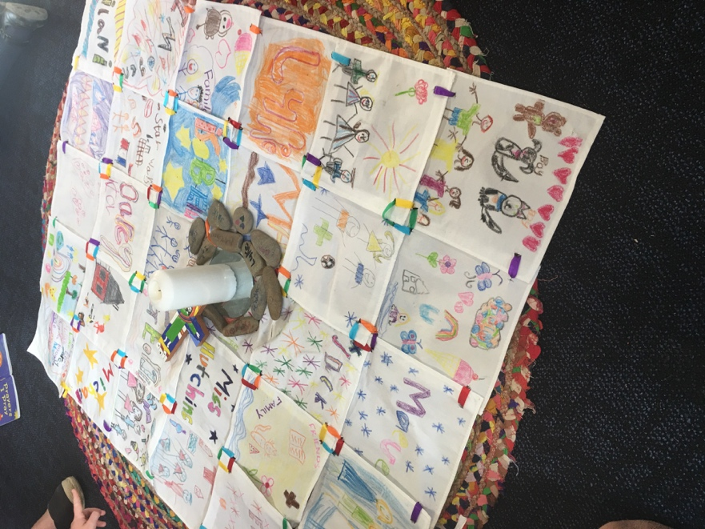

Learning & Teaching

Goals & Intended Outcomes
To inspire our students to find their spark, their passions, their strengths and to guide and support them on their learning journey.
• Develop a school wide culture of learning built on high expectations of each student.
• Develop shared vision for the teaching of literacy and numeracy.
• Learn more about and incorporate Reggio Emilia practices into our teaching practice.
• Strengthen team capacity to ensure planning is targeted to achieve optimal student success.
• Facilitate teacher development through collegial planning.
• Budget focus on literacy, numeracy, wellbeing.
• Strengthen educational provision for students with learning needs, including gifted and talented students.
• Explore and implement best practice philosophy and pedagogy with a clear focus on engagement, critical thinking and creativity.
At Lisieux, we strive to challenge each individual and enhance their sense of personal worth through the building of a respectful and rigorous learning community. The curriculum seeks to engage all students and provide a transformational education, with the highest quality pedagogy, tailored to inspire a love of learning and respond to individual needs. As a Catholic school, Religious Education is at the centre of our School’s curriculum.
The school curriculum is based on the Victorian Curriculum, which has provided Lisieux with a strong standardised curriculum development and implementation framework. All learning is underpinned by well-developed frameworks, and staff work in teams to plan, reflect and review units of work, and student progress. Staff were involved in systemic professional development that centred on key goals.

Achievements
In 2018, a focus on developing the learning community became part of our annual action plan focus. In particular, we strived to inspire our students to find their spark, their passions and their strengths. Staff utilised the Victorian Curriculum to provide a consistent approach to planning and moderation.
In 2018, Lisieux utilised Seesaw as a means of sharing student learning with families. Parents were able to access lesson examples, assessment tasks and continual feedback. Student learning was celebrated in a range of forums, for example, our Inaugural Art Show, Genius Hour expo, displays, Student Learning Conferences, etc.
Lisieux measures success in many ways, and such data is used to assist teachers to provide curriculum and learning that is differentiated to students’ needs. In 2018, Lisieux did not have any students sitting NAPLAN tests.
PROPORTION OF STUDENTS MEETING THE MININUM STANDARDS
NAPLAN TESTS | 2016  % | 2017  % | 2016 - 2017  Changes  % | 2018  % | 2017 - 2018  Changes  %

At Lisieux, we recognise that students learn at different rates, have different strengths, and need support in different areas.
The Learning Diversity Leader works to enable the diversity of skills and talents of all students within the School to be nurtured. Specialist support in the form of differentiation within our mixed ability classes allows us to cater for a diversity of learning needs. Appropriate intervention may include:
• Classroom support. • Individual and small group intensive support. • Personal Learning Plans
• Learning programs used to support literacy and numeracy.

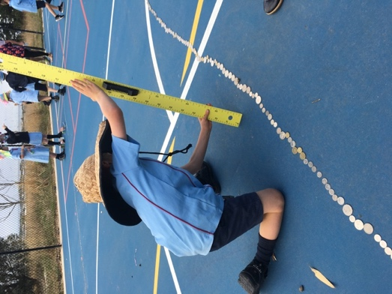

Learning at Lisieux is about more than what happens inside the classroom. We are passionate about learning for life. Our co-curricular program is fundamental to enabling students to identify and build upon their strengths, to learn more about themselves and others.
Students are encouraged to be involved in a wide range of co-curricular opportunities, designed to foster their personal, spiritual, intellectual, social and emotional development. The range of activities offered by our School encourages students to be active members of their school and local community. Such activities provide students with the opportunity to develop new interests, increase their social network, foster teamwork skills and build leadership abilities.
At Lisieux, development of the whole person is encouraged through experiential opportunities that build on students’ concept of their place in the world. We believe that excursions offer experiences that are not possible within the traditional classroom setting and that such experiences equip students with the skills and values that will promote healthy attitudes and foster a sense of belonging. Excursions can greatly enhance learning by offering new, challenging and practical experiences across all learning areas. They are designed to develop a range of skills and values, including communication, responsibility, leadership, resilience, self -worth and teamwork.
Some of the excursion experiences at Lisieux throughout 2018 included:
Whole School Trip to Werribee Zoo and to the Archibald Prize Exhibition at Geelong Gallery; Beach excursions; visit to Narana. Lisieux Prep children had a social excursion with Prep children from St Therese CPS.

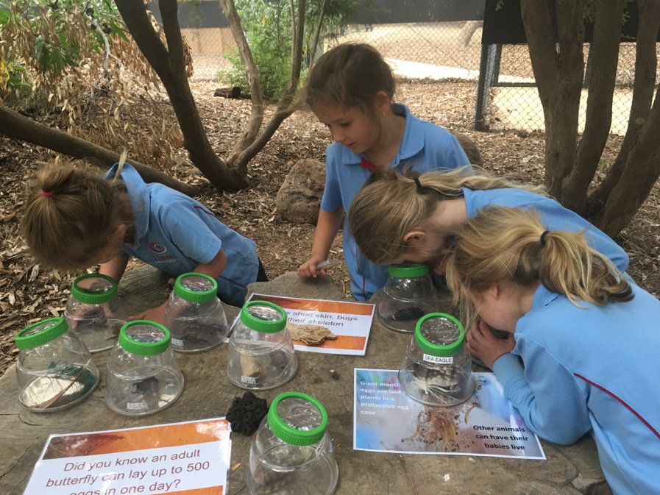
Student Wellbeing

Goals & Intended Outcomes
To develop a community that fosters positive, respectful reciprocal relationships between all of its members.
• Meeting structures that encourage input and participation, sharing of ideas and responsibility.
• Structures to enhance collegiality as a means of professional learning.
• Formally introduce and train all staff in Restorative Practice Framework, so that this is uniformly adopted as a means to manage conflict.
• Develop programs and opportunities to foster caring and respectful relationships, the identification of individual character strengths, and skills such as resilience in all students.
• Maintain profile as a school dedicated to Positive Education and continue resourcing and education in this area.

• Engage in ongoing partnership as a Visible Wellbeing school.

At Lisieux, the provision of pastoral care is of the utmost importance. We respect the dignity of each student and strive to nurture each individual, recognising that if young people feel a sense of attachment and belonging at school, their overall wellbeing will be improved, and with it their chances of academic success. The development of quality relationships amongst students, and between students and teachers, is essential in building a nurturing social environment.
Within the School, pastoral care is organised within and around the Class group and the whole school group. Educators have a vital role in getting to know each individual in their care, fostering a sense of belonging and connectedness, encouraging positive behaviours and being alert to difficulties that the students in their care may be experiencing. The Class teacher is that person ‘at the coal face’ so often most closely connected to the daily life of the student and their role in the life of our students cannot be underestimated. The maxim that ‘every teacher is a teacher of pastoral care’ is certainly true of the staff at Lisieux. From the incidental conversations which occur as students arrive to class each morning to the way that staff provide clear but safe boundaries for student behaviour, the School strives to reinforce the message that each member of the learning community is accepted and valued for the gifts that they bring.
The development of the whole person is the fundamental focus of behaviour management practices at Lisieux. Every student is encouraged to grow spiritually, intellectually, emotionally and socially. Self-management, the acceptance of personal and group rights and responsibilities, and the maintenance of effective behaviour management practices and procedures underpin behaviour management at the School.
A House system operates with all students are assigned to a particular House: Bundjil; Parrwang; Kunuwarra and Gherang. The House system also helps to build a sense of community and connectedness.

Achievements
As a foundation school, Lisieux embraced Positive Education as a holistic approach to wellbeing, inspired by the work of Martin Seligman. In simple terms, this is the pursuit of and personal growth in positive emotions, positive relationships, positive engagement, meaning and accomplishment and health. Professional learning was offered to staff in positive psychology, facilitated by Visible Wellbeing, an organisation developed by Professor Lea Waters. Classes from Prep - Year 3 explored a range of gratitude practices, mindfulness activities and meditation practices, and were encouraged to recognise character strengths in both themselves and others.

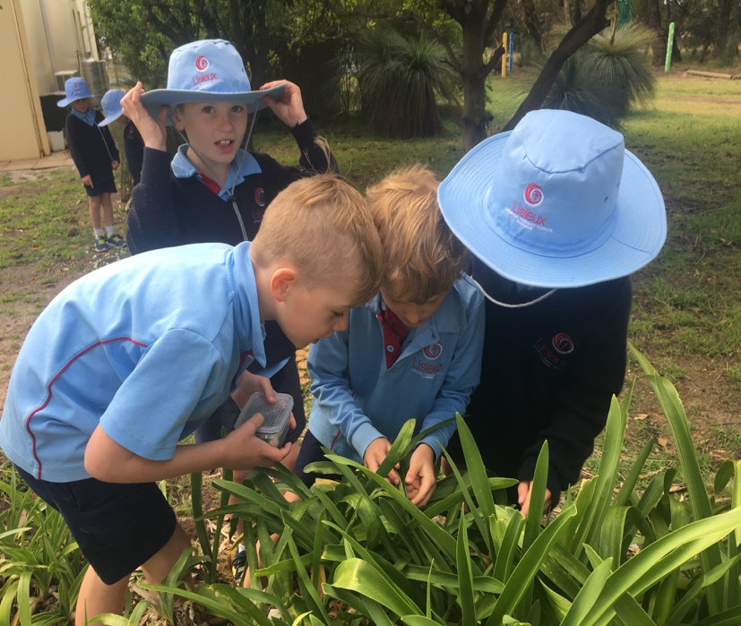

Building Whole School Community
At Lisieux, we celebrate community in many ways. In 2018, we held a whole school Art Show which was a great success, a showcase of work across the Arts. Artworks and 3D creations by students from all levels were displayed and local artists and volunteers shared work, some of which was available for silent auction. A range of musical performances engaged the audience of students, staff and family members throughout the 3-day show.
In November, we celebrated our inaugural Sports Carnival Day, held at the local Torquay oval. Students from all levels participated with energy and enthusiasm, with Parrwang House enjoying the overall win on the day.
Nurturing community involves working in partnership with families and these partnerships are an important aspect of School life. Early in the year, in February, our Family Picnic took place, a social evening with great levels of participation. We celebrated the role of mothers at our “Mums’ High Tea” focused on acknowledging and celebrating the incredible role of mothers in our community, and this focus extended to step mums, grandmas, aunts and other significant role models. Just prior to Fathers’ Day, we hosted our “Dads’ Breakfast” with a large number of fathers, grandpas or special male role models coming along to share breakfast with their son, daughter or grandchild.
Lisieux also supports and encourages the role of parents through invitation to celebrations such as the Commissioning Mass; Information evenings; social celebrations such as Winery Tour and Dads’ Night; volunteer support with the reading program; and, membership on the School Advisory Council Board and other committees such as the Parents and Friends.
We value our partnership with parents and learning conferences with the Class teacher provided an opportunity to understand each student better. We recognise the Class teacher and their daily interaction with students as a significant point of contact for parents.

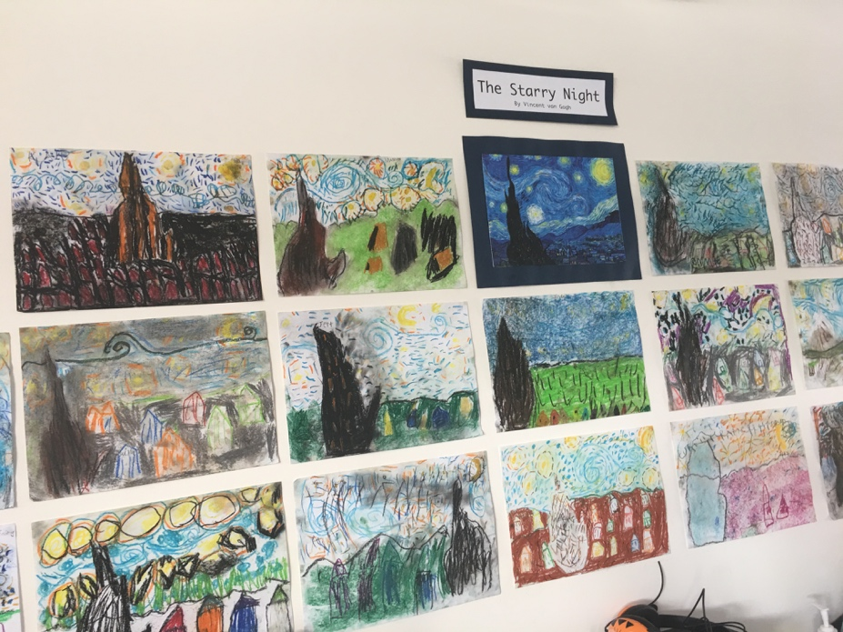
A Restorative Practice Framework:
We believe that students, staff and parents must be well supported and treated with equity and justice. We understand that the most profound learning occurs when healthy relationships exist. Restorative Practice is a strategy that seeks to build, maintain and restore relationships that have been harmed. We expect that all members of our learning community act as witnesses to the gospel values of respect, justice and love for our neighbour. Restorative Practices will help build capacity to enable students to manage their behaviour and contribute to the improvement of learning outcomes. A Restorative Practice framework focuses attention on the quality of relationships within the entire learning community. This presumes an acceptance of clear and reasonable expectations and an acknowledgement of personal accountability.

Every member of the School community is encouraged to commit to:
- The Catholic ethos of the School
- The Creed of Rights and Responsibilities
- School expectations / procedures
Staff and parents are encouraged to help students:
- Give witness to the message of the Gospel
- Affirm the essential goodness of each individual
- Respect the dignity of the human person through consideration and courtesy
- Develop a sense of responsibility for actions and their consequences
- Develop the capacity to re-affirm, repair and rebuild relationships
- Develop reflective practices in relation to behaviour
- Trust in and commit to fair process
STUDENT SATISFACTION
Processes are in place at Lisieux to gather feedback in an ongoing manner on a range of matters and to improve communication generally. While there was no formal survey undertaken in 2018, there were opportunities for parents, students and staff to indicate their level of satisfaction with the School.
During the year, many students were affirmed for their contribution to the life of the School. Principal’s Awards at assembly and affirmation postcards were presented to acknowledge service, effort and endeavour, achievement and individual character strengths. These achievements were also frequently shared with the wider community through the newsletter and via the School Facebook page.

STUDENT ATTENDANCE
The importance of students attending school cannot be understated. Regular attendance at school reinforces routine behaviours, allows students to be part of a sequenced learning experience, provides opportunities for feedback to be given and assists with the development of social skills such as teamwork, resilience, friendship building. The purpose of the Attendance Policy is to specify the procedures used by the School to encourage and monitor attendance of students and to outline the roles of School staff with regard to student attendance, including:
- Maintaining accurate records of all enrolled students;
- Maintaining attendance checking procedures which enable the School to identify and assist students with unsatisfactory attendance;
- Providing prompt, positive intervention measures, so that students do not fall behind with their work;
- Developing sound communication links between school and parents concerning school attendance.
Regular attendance at school is essential if students are to maximise their potential. The School, in partnership with parents, is responsible for promoting the regular attendance of students. While parents are legally responsible for the regular attendance of their children, School staff, as part of their duty of care, monitor part or whole day absences. In 2018 we used an electronic role marking system through nForma. This system enabled staff to carefully monitor student attendance as the roll is completed in morning gathering and again in the afternoon. Accurate reports can be produced for each student our Administration Officer is required to follow up any student absence and adjust the roll accordingly based on communication with parents. A step by step procedure for managing student non-attendance is followed according to our School policy. The Principal is responsible for supporting the regular attendance of students by ensuring that:
- Parents and students are regularly informed of attendance requirements and the consequences of unsatisfactory attendance;
- All cases of unsatisfactory attendance and part or full day absences from school are investigated promptly and that appropriate intervention strategies are implemented;
The average student attendance rate for 2018 was 92.4%. Annual attendance rates disaggregated by Year group are listed below:

AVERAGE STUDENT ATTENDANCE RATE BY YEAR LEVEL | %
Y01 | 91.7
Y02 | 93.0
Y03 | 84.9
Overall average attendance | 89.9

Child Safe Standards

Goals and Intended Outcomes
The VRQA Compliance Self-Assessment and Action Plan was visited in 2018 to monitor our implementation and compliance with Ministerial Order no. 870.
Lisieux has addressed the CECV Commitment to Child Safety in the following ways:
• Implementation of Child Safety Policy;
• Implementation of Code of Conduct;
• Clear procedures for engaging volunteers and informing the community of the implications of the Child Safe Standards;
• Promotion of child empowerment and participation.

Achievements
The Principal attended a range of professional development sessions to remain informed of the requirements of compliance, in relation to Ministerial Order 870 that prescribes specifically what schools must do in order to comply with Child Safe Standards.
Lisieux has completed the VRQA Compliance Self- Assessment and Action Plan. Policies have been formulated on Child Safety Code of Conduct, Child Safety and Protection Policy, Respectful Relationships Policy, and Parent Code of Conduct. These are on the School website and available to parents and community members.
Professional Development with staff has been conducted in relation to:
• Child Protection- Reporting Obligations;
• “PROTECT”- responding to Incidents, Disclosures and Suspicions of Child Abuse;
• Victorian Reportable Conduct.
Lisieux has informed staff about Standards 4 & 5 of the Ministerial Order 870. It has used the guidelines as set out by CECV for employing new staff. Relevant information posters have been displayed throughout the staff work areas.

Leadership & Management

Goals & Intended Outcomes
To develop an inclusive team that is passionate and supportive of all.
• Develop clear communication protocols with all stakeholders, which ensure all voices were welcomed and listened to;
• Develop a whole school professional learning plan;
• Shared POL roles and responsibilities.

Achievements
In 2018, the Principal was focused on providing a learning environment where every individual would be supported to achieve positive outcomes, and encouraged the growth of teacher capacity through professional development and collegial planning. All staff were provided with opportunities to build their knowledge and skills in a range of areas. Staff were encouraged to engage in professional development, relevant to their individual needs and consistent with the Lisieux Annual Action Plan.

EXPENDITURE AND TEACHER PARTICIPATION IN PROFESSIONAL LEARNING
DESCRIPTION OF PL UNDERTAKEN IN 2018
Staff spirituality; First Aid Training; Visible wellbeing; THRASS; nForma Training; Literacy; Positive Schools Conference; NCCD Training; Leading Languages; Apple Education; Inquiry Professional Development; Middle Leaders Summit; Identifying and Responding to Abuse; Strategic and Innovative Leadership National Conference.

NUMBER OF TEACHERS WHO PARTICIPATED IN PL in 2018 | 6
AVERAGE EXPENDITURE PER TEACHER FOR PL | $2275
The teaching staff at Lisieux Catholic Primary School is committed to excellence in teaching and learning. The staff at the School is highly qualified and an experienced group of professionals who give generously to all aspects of School life.
Below is a table that overviews the academic qualifications of each of the teaching staff at Lisieux in 2018 as well the number of years of teaching experience of each staff member.

Teacher qualifications for 2018 are as follows:
TEACHER QUALIFICATIONS
Doctorate |  | 16%
Masters |  | 50%
Graduate |  | 0.0%
Graduate Certificate |  | 0.0%
Bachelor Degree |  | 66.6%
Advanced Diploma |  | 7.7%
No Qualifications Listed |  | 0%

Surname | First Name | Position of Responsibility | Years of  Experience | Qualifications
Dando | Ronald | Teacher / Religious Education Leader | 15 | MRE, B.Ed
Hutchins | Georgia | Teacher | 7 | MTeach, BA
Kentish | Leigh | Teacher | 9 | Dip.OutEd, B.Ed
Moody | Holly | Teacher | 11 | B.Ed
Righetti | Therese | Teacher | 26 | Dip Ed; Dip Vis Arts
Ryan | Susan | Principal | 33 | EdD (Education), M. Ed (Research), Post Grad Dip (Student Welfare), B. Ed, Dip Ed.
Vagg | Zoe | Teacher | 10 | B. Ed.

Years of Experience | Number of Teachers
<1 year | 0
2 – 5 years | 0
6 – 10 years | 2
11 – 20 years | 3
>21 years | 2

Staff Composition, Attendance and Retention
The teaching staff retention rate at the end of 2018 was 87%. This indicates the number of teachers who have continued service at Lisieux from 2018 into 2019. Staff attendance rate is shown in the table below:

TEACHING STAFF ATTENDANCE RATE
Teaching Staff Attendance Rate | 97.7%

As well as the teaching staff, Lisieux also had a total of 2 full staff members employed for administrative and clerical duties.
The staff at Lisieux is comprised of a number of different characteristics. These characteristics for 2018 are detailed below:

STAFF COMPOSITION
Principal Class (Headcount) |  | 1
Teaching Staff (Headcount) |  | 6
Teaching Staff (FTE) |  | 3.6
Non-Teaching Staff (Headcount) |  | 2
Non-Teaching Staff (FTE) |  | 2.8
Indigenous Teaching Staff (Headcount) |  | 0

TEACHER SATISFACTION
Lisieux did not complete School Improvement Surveys in 2018 as it was our foundation year.

School Community

Goals & Intended Outcomes
• To proactively build a strong sense of connection between the stakeholders within the Lisieux community that embodies the values of trust, inclusion and commitment.
• Create opportunities for welcome of all key stakeholders in our learning community.

Achievements
As a new school community at the beginning of 2018, Lisieux welcomed 8 members of staff, 43 students and their families. All were encouraged to be involved in the life of the community and a range of initiatives was introduced including:
• Family Picnic Evening;
• Establishment of Parents and Friends Committee and Advisory Council;
• Mothers’ Day High Tea and Fathers’ Day Breakfast;
• Art Show;
• Fundraising events such as Bunnings Sausage Sizzle, Winery Tour;
• Liturgies and assemblies;
• Weekly newsletter, The Tide, as well as Instagram and Facebook accounts as a means of communicating with families.

