Contents

Torquay North, 3228
Lisieux Catholic Primary School
INSERT SCHOOL LOCATION
ANNUAL
REPORT
TO THE SCHOOL
COMMUNITY
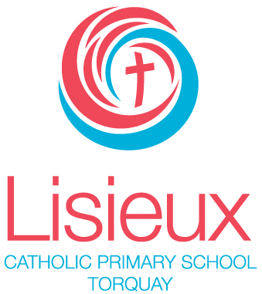
REGISTERED SCHOOL NUMBER: 2221

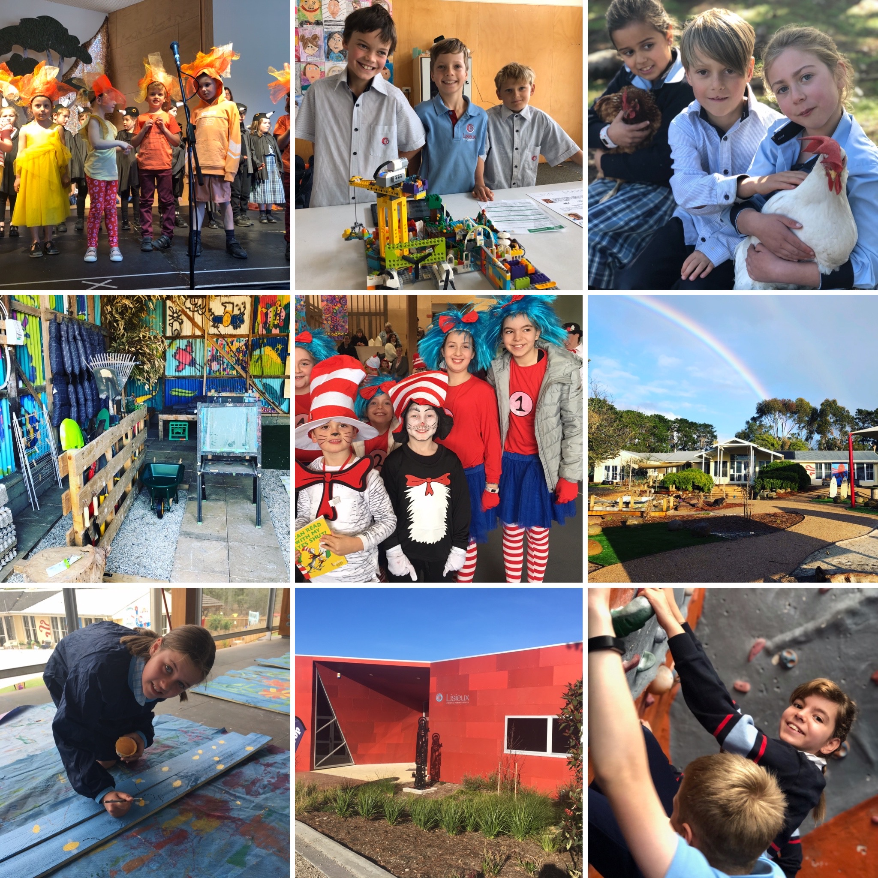

2019
Contact Details 2
Minimum Standards Attestation 2
Our School Vision 4
School Overview 6
Principal’s Report 8
Education in Faith 9
Learning & Teaching 12
Student Wellbeing 17
Child Safe Standards 23
Leadership & Management 25
School Community 30

Contact Details
ADDRESS | 90 South Beach Road,  Torquay, Victoria. 3228.  [Suburb] VIC [Postcode]
PRINCIPAL | Dr Susan Ryan
PARISH PRIEST | Fr Linh Tran
SCHOOL BOARD CHAIR | Mr Michael Timms
TELEPHONE | (03) 90896614
EMAIL | principal@lisieux.catholic.edu.au
WEBSITE | https://lisieux.catholic.edu.au
E NUMBER | 1406

Minimum Standards Attestation
I, SUSAN RYAN attest that LISIEUX CATHOLIC PRIMARY SCHOOL is compliant with:
- All of the requirements for the minimum standards and other requirements for the registration of schools as specified in the Education and Training Reform Act 2006 (Vic) and the Education and Training Reform Regulations 2017 (Vic), except where the school has been granted an exemption from any of these requirements by the VRQA
- Australian Government accountability requirements related to the 2019 school year under the Australian Education Act 2013 (Cth) and the Australian Education Regulations 2013 (Cth)
- The Child Safe Standards prescribed in Ministerial Order No.870 – Child Safe Standards, Managing Risk of Child Abuse in School.
- APRIL 1, 2020

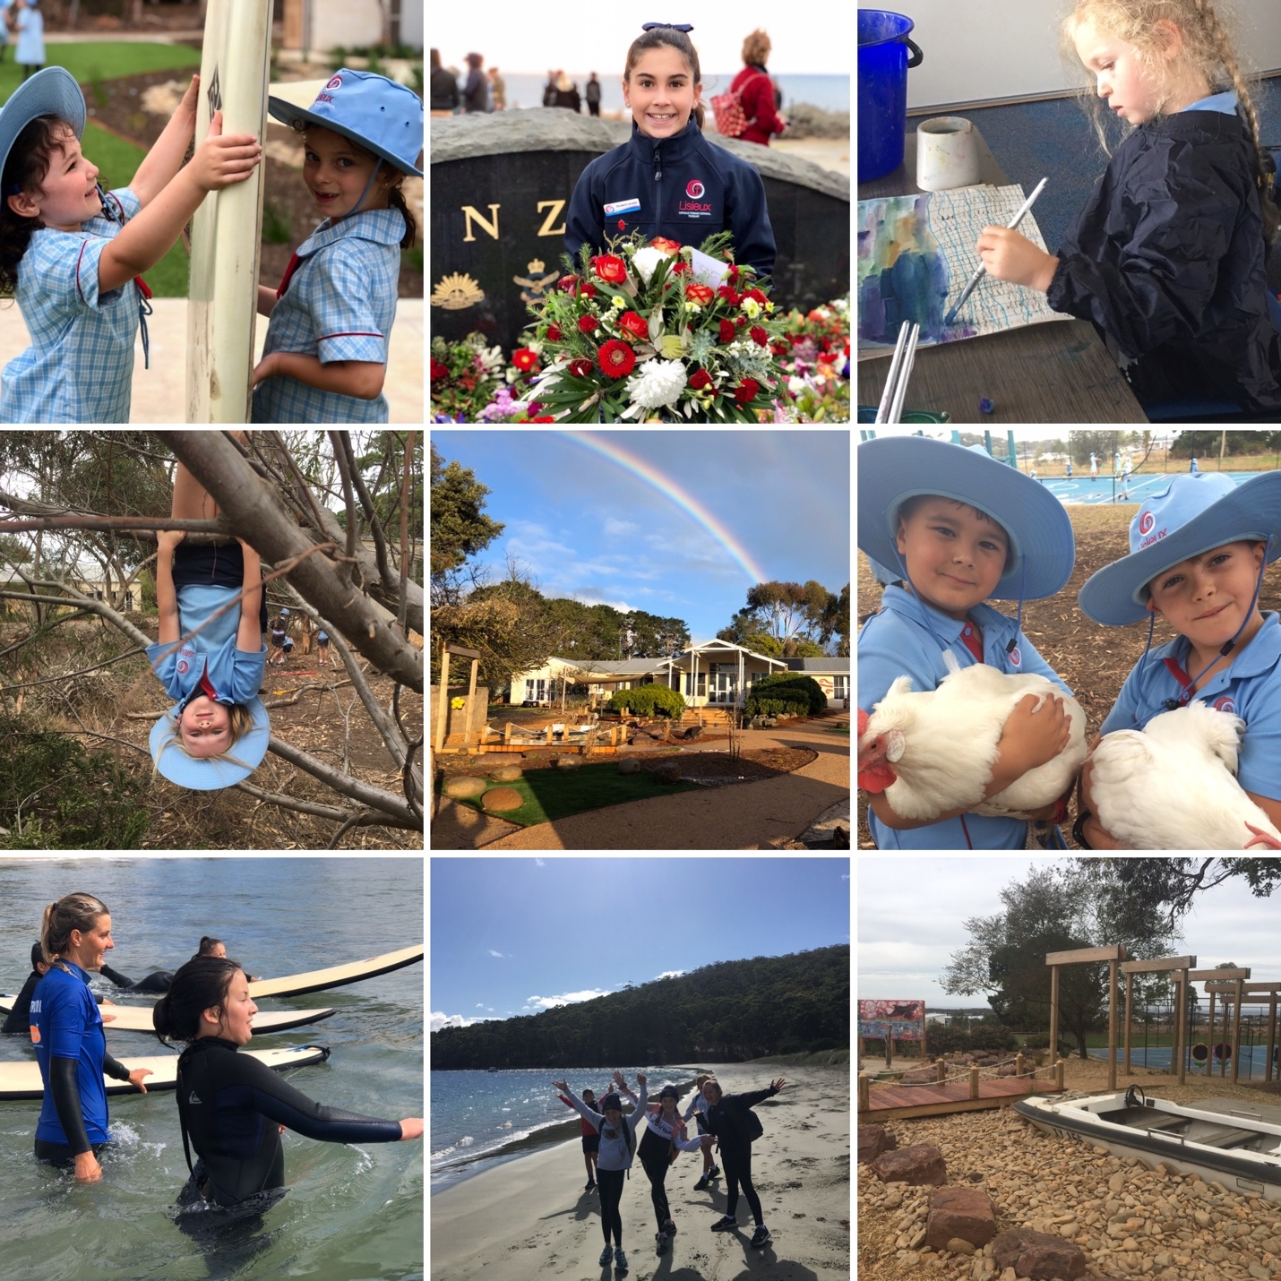
Our School Vision

LISIEUX School vision
In a vibrant school community, and with Christ as our guiding light, we strive to:
- Nurture the development of the whole person as unique individuals made in God’s image
- Foster a love of life, learning and God’s creation
- Pursue fullness of life for all.

LISIEUX School mission
We strive to achieve our vision in the following ways:
- Enabling gospel values to permeate all facets of school life, encouraging each child’s relationship with God
- Providing diverse and engaging learning experiences to meet the needs and learning styles of each student
- Building a culture based on the premise that every child can learn
- Encouraging each student to recognise and nourish their gifts and talents and those of others.

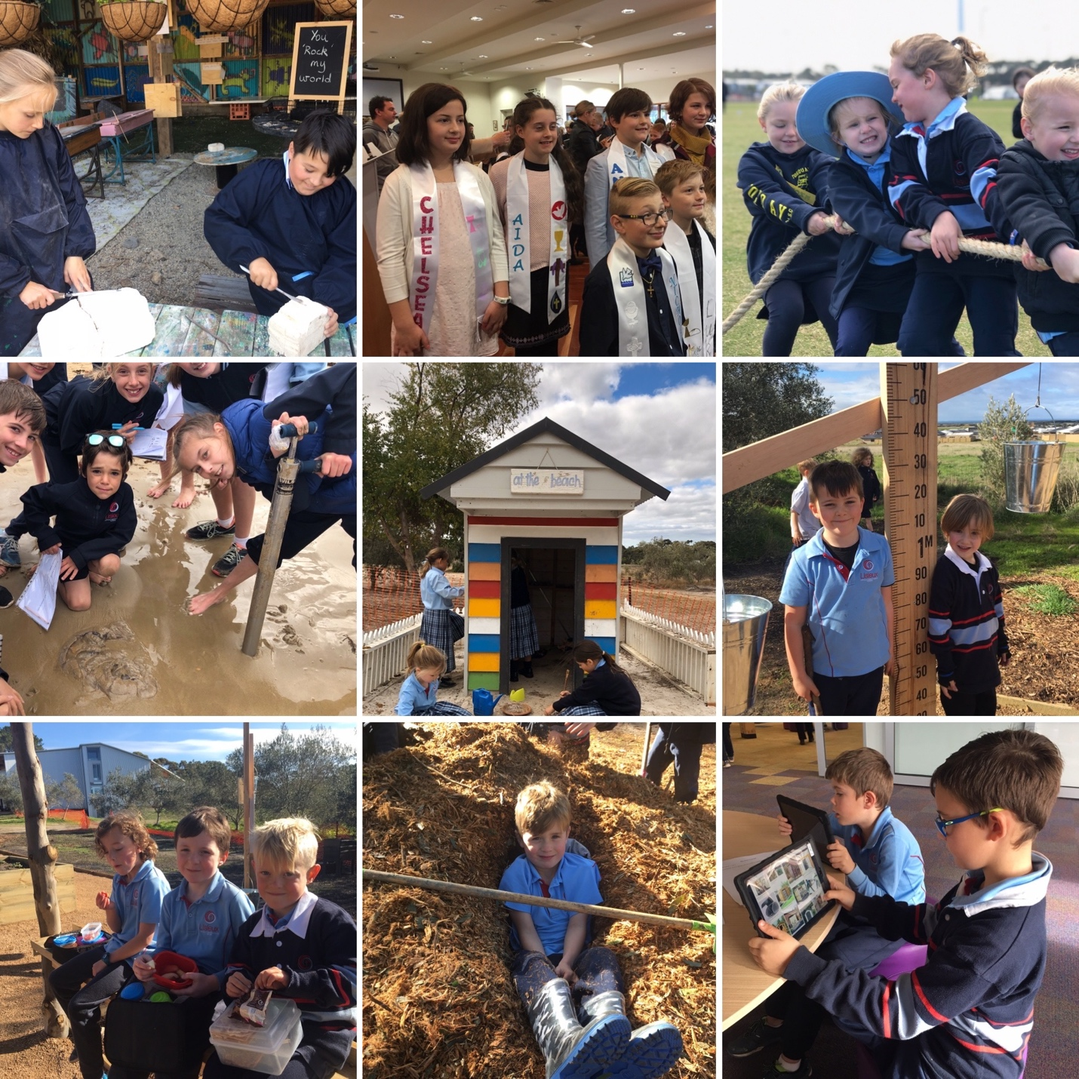

School Overview
Lisieux Catholic Primary School is one of three Catholic primary schools within the Nazareth Parish, and our Parish Priest is Father Linh Tran. In 2018, Lisieux commenced operation as a vibrant Prep -Year 3 co-educational learning community from the site of a former home in South Beach Road, Torquay North, while Stage 1 building works continued. With a small initial cohort of students and a dedicated staff team, a strong community foundation was laid. That foundation has been built upon in 2019 and our community has continued to thrive.
Lisieux’s beautiful setting and natural facilities provide an inspiring environment for its students. The size of our school, which has grown from an initial 43 students in 2018 to 143 students as reflected in the February 2019 census, and 156 students by the conclusion of 2019, has helped to enable a strong sense of belonging. At Lisieux, we believe that the wellbeing of students is fundamental to both their academic and personal success. We understand that students will flourish in a learning environment where they are known, valued and affirmed.
The school is committed to the development of the whole person: spiritual, academic, social-emotional and physical. At Lisieux we strive to ensure that our students are known and loved, nurtured and cared for. Individuals are encouraged to develop their potential, live their faith and contribute to shaping a socially just society with courage, confidence and integrity. Our goal, working in partnership with parents, is to support our students’ educational journey, inspiring them to flourish, to celebrate their many talents and to become advocates of peace and justice.
Inspired by the life of St Therese of Lisieux, our school strives to be a Catholic community where God’s love is experienced, shared and celebrated. Students at Lisieux are supported to discover God’s presence in their daily lives. They are challenged and nurtured to build relationships with others and with God through faith education which includes stories, teachings, rituals, prayer and social action. Lisieux has a close connection to the Parish Church and the students participate in fundraising for Project Compassion and Reach Vietnam.
What makes our school unique is our community of people, our dedication to excellence and our focus on student wellbeing. Our school’s commitment to know and love every student is seen in action every single day. Working in close relationship with our families, we enable each student to develop the skills for life-long learning: creative and flexible thinking, resilience, empathy, generosity of spirit and an understanding of their spirituality. Our staff are highly qualified and committed to innovative teaching practices. Our commitment as educators is to walk with our students on their learning and faith journey, encouraging the students in our care to achieve their full potential. We are constantly challenged to consider new ways to improve our practice in the pursuit of excellence.

Principal’s Report
It is my pleasure to present to you our Annual Report to the Community for the 2019 school year. This Report provides the school community with an overview of the key initiatives and events which have occurred throughout the year, and in a sense, offers a snapshot of our journey thus far. It provides an opportunity for the community to reflect on our achievements and experience a sense of collective pride. At the conclusion of our second year of operation as a learning community, there is much for us to be grateful for at Lisieux. The last 12 months have continued to be a period of incredible growth for our school. We are extremely proud of the school’s comprehensive curriculum, facilities and resources, learning support programs, dedicated teaching and support staff, co-curricular activities and community connections. Parents are very involved in the life of our community, which is highly valued. Students are engaged in an innovative and challenging curriculum, centred around nurturing individual growth, creativity and deep learning.
As Foundation Principal, it has been a great privilege to shape and lead the direction of our community and a key element of this has been achieved through the appointment of quality staff, dedicated to making a profound difference in the lives and learning experiences of children in our care. It is important to acknowledge the wonderful contributions of many people such as staff, parents and students, particularly those who have added so much through their outstanding commitment to our community and its values. Our Advisory Council has provided support to the Principal; advice on strategic planning, school development, policy implementation and general leadership. This team is very much one of support, stewardship and shared representation of the school’s mission. The Parents and Friends Committee has offered significant support in enabling our continued improvement. I am also very grateful for the support and involvement of our Parish Priest, Father Linh Tran, in the life of our learning community.
We are well placed to continue our growth, both in terms of enrolments and our physical structure. We look with confidence to the continued growth of our community.
Dr Susan Ryan
Principal

Education in Faith

Goals & Intended Outcomes
To build a faith community which lives the message of Jesus.
• Strengthen a curriculum that links the message of Jesus Christ to students’ daily lives and contextualises gospel values in a way that is meaningful and assessible.
•Cultivate authentic, respectful and inclusive partnerships between members of the community.
•Use newsletters, social media and other opportunities to communicate our Catholic ethos, using a common language that reflects gospel values.

Achievements
Lisieux Catholic Primary School is a dynamic, faith filled community and has engaged in numerous opportunities throughout 2019 to nurture the spiritual and faith life of its community members. Our Beginning of Year Mass, led by Father Linh Tran, was a fitting way to start the year in our newly completed Multi-Purpose Room. A Commissioning Mass for staff was also held at St Therese Church in February. It was attended by all Lisieux staff and many members of our parent community, being a significant occasion in marking a new step in our journey of growth as a community.
Students continued to participate respectfully in liturgies at focal points throughout the liturgical year, including Ash Wednesday, Easter, our Feast Day, Advent and Christmas. While not all of our students are of the Catholic faith, we believe it is important that they are exposed to the traditions of the Church and the meaning behind the ceremonies and liturgies that take place.
In 2019, we initiated a Parish Fun Run for families of Nazareth, St Therese and Lisieux Catholic Primary Schools. The event was very successful, raising significant funds for our shared REACH Vietnam charity, and helping to unite our communities with a common purpose.
Catholic Education Week took place in March, with a range of activities taking place throughout the school and in Religious Education lessons. Lisieux held its Enrolment Information Evening in this week, sharing with incoming families the importance of spiritual development and faith formation in our school.
In partnership with the parish, the sacrament of Reconciliation was celebrated for 13 Year 3 students in May. In June, 6 Year 4 students celebrated the sacrament of First Eucharist. The sacrament of Confirmation was celebrated in November for 7 Year 6 students.
Our Feast Day was celebrated with a mass and whole school excursion to Geelong Botanical Gardens, linking to St Therese’s love of flowers and the environment.
VALUE ADDED
Students at Lisieux had the opportunity to nurture their own faith through participation in:
• Whole school prayer during assemblies and regular daily classroom prayer;
• Beginning of Year Mass;
• Ash Wednesday Liturgy;
• Caritas Coin Trail fundraiser;
• Easter Liturgy;
• Family masses;
• Community visits to Star of the Sea Aged Care facility;
• Participation in Nazareth Parish Fun Run Reach Vietnam fundraiser;
• St Therese Feast Day mass;
• Reverse Advent Calendar collections for local charity organisations;
• Christmas liturgy and re-enactment play;
• Visible Catholic identity symbols throughout the school.
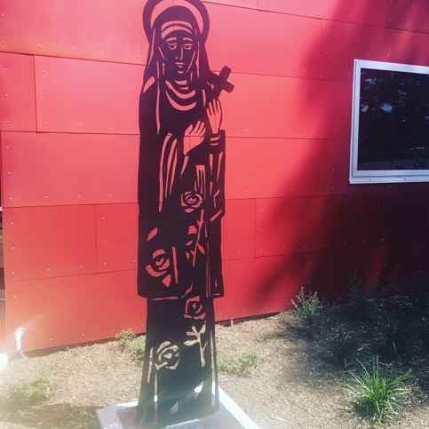

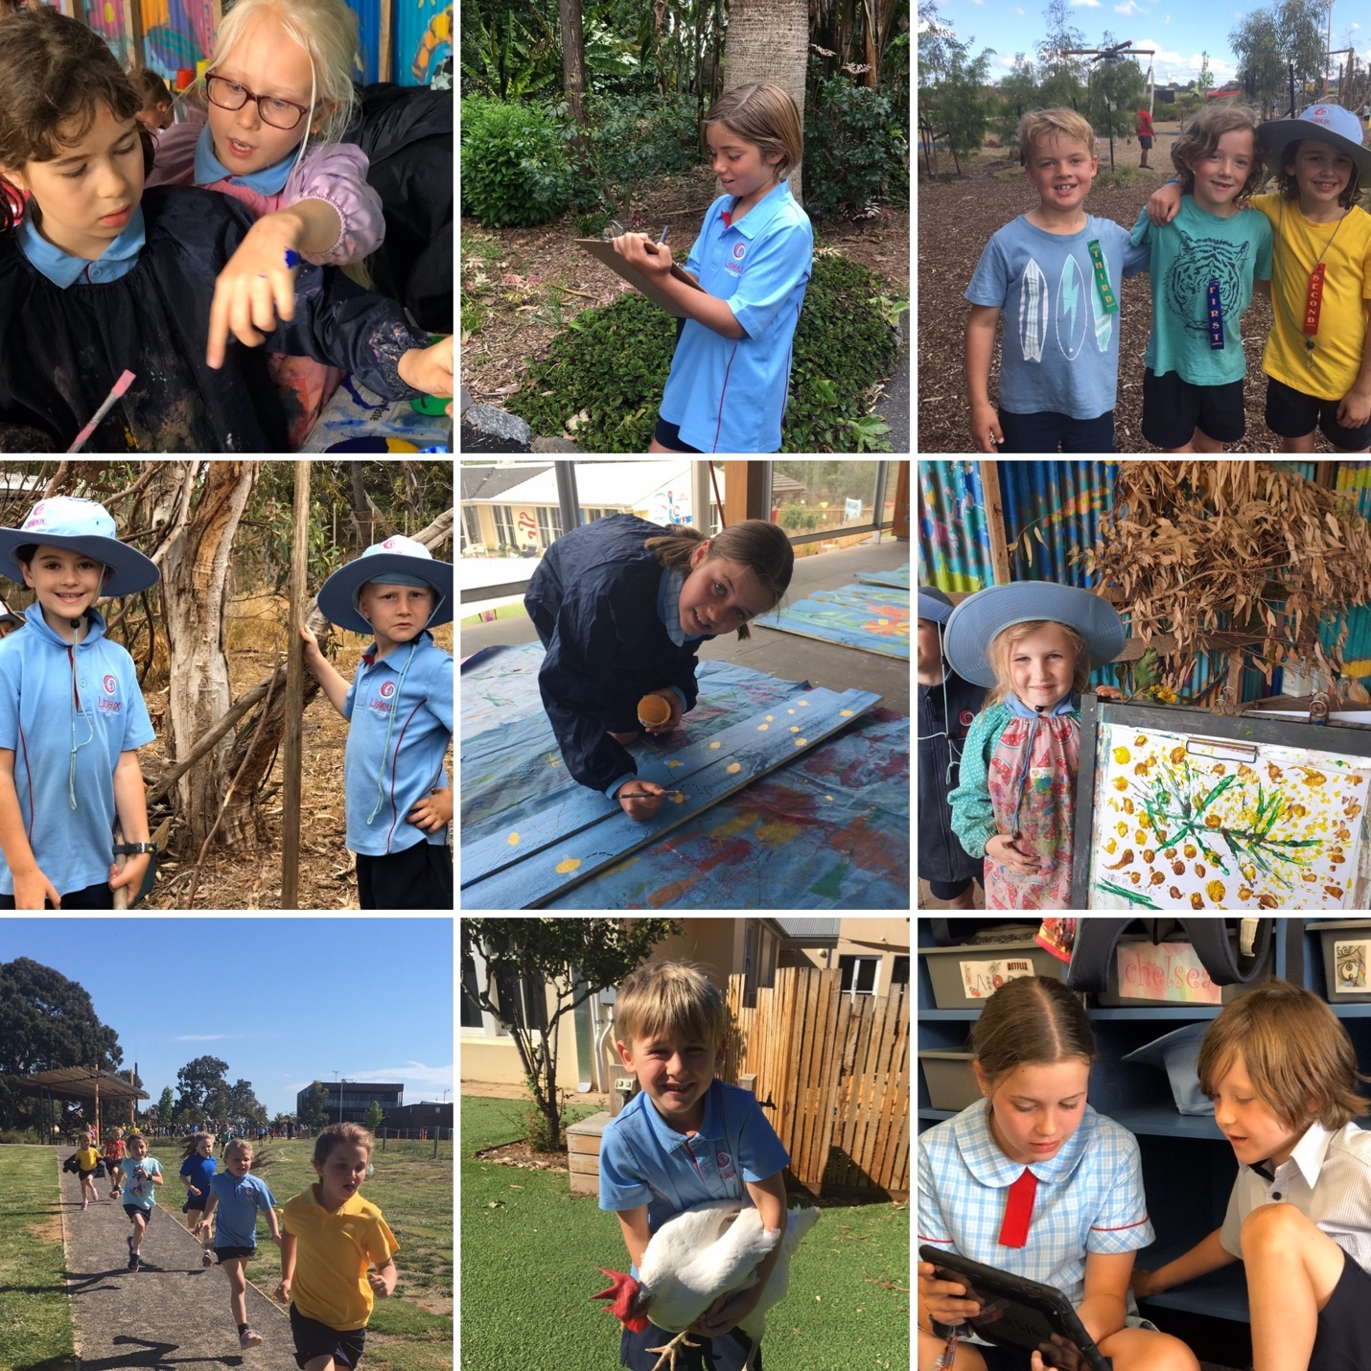
Learning & Teaching

Goals & Intended Outcomes

To nurture the development of a learning culture that values diversity and fosters creativity, curiosity, persistence and passion.
• Teacher development through collegial planning, led by team leaders.
• Explore and implement best practice philosophy and pedagogy with a clear focus on engagement, critical thinking and creativity.
• Through the introduction of a new role, Curriculum and Pedagogy Support Leader, build educators’ capacity to differentiate instruction to meet identified student needs.
• Strengthen educational provision for students with learning needs, including gifted and talented students.
• Engagement in relevant incursions and excursions.

Achievements
Our school curriculum is based on the Victorian curriculum, which has provided Lisieux with a strong standardised curriculum development and implementation framework. While in our first year of operation, we offered places to students in Prep-Year 3, in 2019 our cohort grew to be a community of learners from Prep-Year 6. Consequently, our community of educators also grew, including the appointment of further classroom and specialist teachers and support staff.
At Lisieux, we strive to challenge each individual and enhance their sense of personal worth through the building of a respectful and rigorous learning community. In our second year of operation, with a significantly increased staff team, a key focus was building a strong commitment to the ongoing development of a collaborative culture amongst the staff. To this end, we invested in a shared team planning model, led and overseen by key members of the school Leadership Team. A new position, Curriculum and Pedagogy Support Leader, was initiated, with a key responsibility of this position being to mentor new staff, particularly graduate teachers, assist in guiding planning and goal setting, and in the analysis of student achievement and engagement. The introduction of this role also assisted us in strengthening the capacity of educators to implement differentiated learning and to improve the documentation and implementation of Personalised Learning Plans.
The staff at Lisieux continued to have a strong focus on providing rich learning opportunities for all students. We believe this is best achieved by challenging and motivating students through a rich curriculum and by building teacher capacity. Our commitment to inspiring students to find their spark and identify their strengths led our staff to continue innovative ways of delivering the curriculum. Some new specialist programs were initiated including De’Couverte (a French word meaning ‘go and explore the world’), a cross-age program based on problem solving and solution creation. Additionally, our commitment to outdoor learning was further embedded, and we endeavoured to integrate this into both specialist and standard curriculum programs, knowing that research strongly supports time spent outdoors as a means of promoting mental health and wellbeing as well as social and academic development.
Our students have a strong interest in The Arts and in 2019 we produced our first whole school musical, What the Birds Saw, led by Ms Tess Righetti. The production showcased the talents of our students, dedication of staff and involvement of parents.
We are truly blessed at Lisieux to have a team of dynamic teachers who are dedicated to providing our students with the best opportunities for learning. Our staff also recognise themselves as learners and continually work to update their skills, knowledge and vision of education. Professional learning remains a high priority of the leadership team and is highly valued by all members of staff.
VALUE ADDED EXPERIENCES TO LEARNING AND TEACHING
• Year 5/6 Camp to Bruny Island, Tasmania;
• Community visits to Star of the Sea Aged Care facility;
• Prep-Year 2 Outdoor Discovery Program;
• Year 3-6 De’Couverte Program;
• Specialist programs including The Growth Project; 100 Languages; Mind & Body: Literacy Enrichment;
• French language immersion;
• Maintained termly PSG meetings for students with additional needs;
• Intervention to further develop literacy and numeracy skills;
• Incorporation of professional reading into staff meetings;
• Implementation of deep learning experiences in Inquiry based learning;
• Parent evening “Positive Education” facilitated by Andrea Downie;
• Excursions to Werribee Zoo, Geelong Art Gallery, You Yangs; Marine Discovery Centre; Geelong Botanical Gardens; Suessical The Musical; Teaching Kids Conference. Incursions included Responsible Pet Ownership; Geelong Cats Healthy Heroes visit; Craft Power; Bike Education.
• Whole school Production, “What the Birds Saw”;
• Small group Great Victorian Bike Ride.

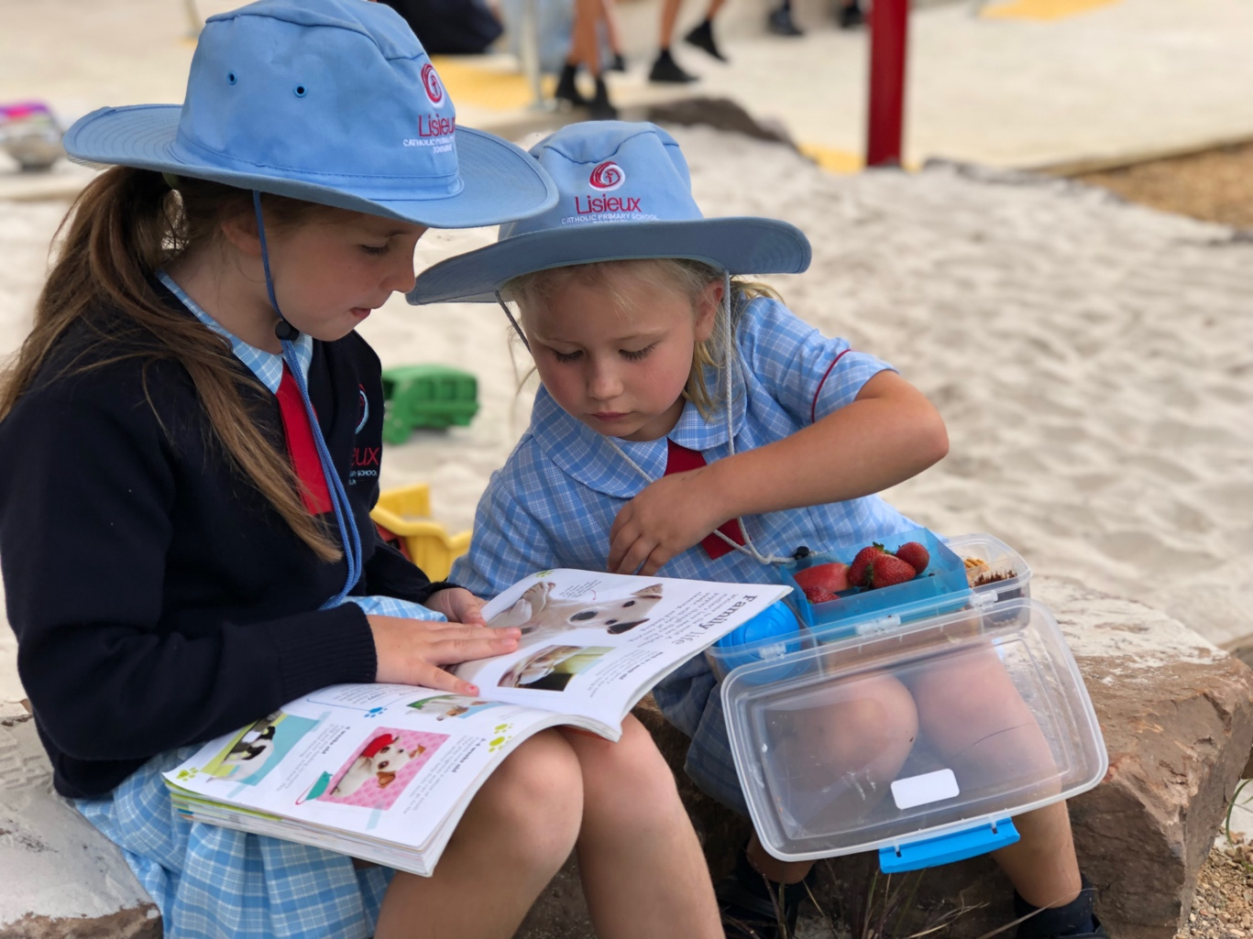

STUDENT LEARNING OUTCOMES
2019 was the first year that Lisieux students participated in NAPLAN. In 2019, 20 students in Year 3 and 13 students in Year 5 completed the NAPLAN tests.
The table below indicates the percentage of students at each level who completed each of the NAPLAN tests. The following table and graph below also indicate the percentage of students who met or exceeded the National Minimum Standards in Reading, Writing, Language Conventions (Spelling, Grammar and Punctuation) and Numeracy.
PROPORTION OF STUDENTS MEETING THE MINIMUM STANDARDS
NAPLAN TESTS | 2017 % | 2018 % | 2017 - 2018 Changes % | 2019 % | 2018 - 2019 Changes %
YR 03 Grammar & Punctuation | 0.0 | 0.0 | 0.0 | 95.0 | 0.0
YR 03 Numeracy | 0.0 | 0.0 | 0.0 | 90.0 | 0.0
YR 03 Reading | 0.0 | 0.0 | 0.0 | 95.0 | 0.0
YR 03 Spelling | 0.0 | 0.0 | 0.0 | 95.0 | 0.0
YR 03 Writing | 0.0 | 0.0 | 0.0 | 100.0 | 0.0
YR 05 Grammar & Punctuation | 0.0 | 0.0 | 0.0 | 100.0 | 0.0
YR 05 Numeracy | 0.0 | 0.0 | 0.0 | 100.0 | 0.0
YR 05 Reading | 0.0 | 0.0 | 0.0 | 100.0 | 0.0
YR 05 Spelling | 0.0 | 0.0 | 0.0 | 100.0 | 0.0
YR 05 Writing | 0.0 | 0.0 | 0.0 | 92.3 | 0.0

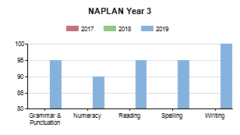
At Lisieux, we recognise that students learn at different rates, have different strengths, and need support in different areas. Lisieux measures success in many ways, and such data is used to assist teachers to provide curriculum and learning that is differentiated to students’ needs. As a new school, the NAPLAN data is not unsurprising, reflecting the fact that students have come from several different feeder schools, have been at Lisieux for a short period of time, and that some of our students have chosen Lisieux for a fresh start. At Lisieux, we have a reasonably high level of students who have additional learning needs. Most significantly as a new and growing school, our focus in our first year has been on building a strong sense of community, of ensuring that students feel safe and connected. We believe that dedicating effort to this area, will ultimately reap strong academic results.
We also used the following strategies to impact student learning outcomes:
• Visible Learning – focusing on learning intentions and success criteria;
• Feedback to students;
• Guided reading and reciprocal reading.

Student Wellbeing

Goals & Intended Outcomes

To build a culture that is committed to and celebrates fullness of life.
• Explicitly value the giftedness and diversity of each member of our learning community.
• Develop initiatives to foster collaborative and respectful relationships and to promote equity and justice throughout the community.
• Encourage opportunities for multi-age learning and social opportunities.

Achievements
In 2019, Lisieux continued its commitment to Positive Psychology practices. Underlying our explicit focus on wellbeing is the premise that if young people feel a sense of attachment and belonging at school, their overall wellbeing will be improved, and with it their chances of academic success. We continued to invest in a range of gratitude practices, daily mindfulness and meditation practices, and introduced Focus of the Fortnight to explore character strengths in more detail.
To further extend our commitment to fostering quality relationships and building a shared understanding of Positive Education, the staff undertook a two-day Wellbeing / Positive Education Professional Development, led by Andrea Downie of Project Thrive. The school Leadership Team researched best practice approaches to facilitate engagement and behaviour and a full day Professional Development session on Restorative Practice was undertaken by all members of staff.
Being the first year of operation with senior students, it was decided to host a 2-day Leadership Conference for Year 5/6 students, all of whom were appointed to a leadership position. Each one of these students also took on the role of ‘buddy’ to a Prep student and this, along with other experiences, gave them an authentic leadership encounter. Our senior students also participated in a 4 day camp to Bruny Island, Tasmania, the location being chosen as it aligned with many of Lisieux’s key principles ie. sustainability, mindfulness, outdoor learning.
In 2019, community was celebrated in many ways. We facilitated a whole school production, in which all students were involved. The performances ran over two evenings and were well-attended by families and community members. Artist-in-residence Chris Sage worked with students to design and install House murals, and a number of house-based events were held throughout the year, including Beach Activities Day, Cross Country and Athletics Carnival. Mothers’ Day High Tea and Fathers’ Day Breakfast were well-attended as was Grandparents’ Day.
VALUE ADDED
• Daily mindfulness;
• Daily Gratitude Circles;
• Welcome Family Night at the start of the year;
• Further enhancement of our outdoor learning and playing spaces;
• Parents attended Learning Conferences, Information Evenings and Sacramental Preparation Evenings;
• Year 5 /6 Leadership Conference;
• Buddy program commenced;
• Anzac Day and Remembrance Day were honoured;
• Year 5/6 camp to Bruny Island;
• Whole school development of “language of Lisieux” and graphic interpretation of results into wall art and postcards;
• Circle Time practices;
• Year 3 / 4 Sleepover;
• Pyjama Day;
• School production “What the Birds Saw”;
• House-based carnivals and events;
• Year 2 Pyjama Feast Dinner;
• Grandparents’ Day;
• Monthly birthday morning teas with the Principal;
• Transition programs and Information Sessions for incoming families.

STUDENT SATISFACTION
Processes are in place at Lisieux to gather feedback in an ongoing manner on a range of matters and to ensure communication is transparent. A CEMSIS survey was undertaken in 2019, however, the timing of the survey was challenging and it was felt that the responses were impacted by this. Feedback about students’ sense of belonging was positive as was data about teachers’ respect towards students, students’ learning disposition. The survey data highlighted several key areas that the Lisieux staff would like to focus on in the following year, namely student agency / voice and student leadership.
During the year, many students were affirmed for their contribution to the life of the school. Principal’s Awards at assembly and affirmation postcards were presented to acknowledge service, effort and endeavour, achievement and individual character strengths. These achievements were also frequently shared with the wider community through the weekly newsletter and via the school Facebook page.

STUDENT ATTENDANCE
The importance of students attending school cannot be understated. Regular attendance at school reinforces routine behaviours, allows students to be part of a sequenced learning experience, provides opportunities for feedback to be given and assists with the development of social skills such as teamwork, resilience, friendship building. The purpose of the Attendance Policy is to specify the procedures used by the school to encourage and monitor attendance of students and to outline the roles of school staff with regard to student attendance including:
• Maintaining accurate records of all enrolled students;
• Maintaining attendance checking procedures which enable the school to identify and assist students with unsatisfactory attendance;
• Providing prompt, positive intervention measures, so that students do not fall behind with their work;
• Developing sound communication links between school and parents concerning attendance.
Regular attendance at school is essential if students are to maximise their potential. The school, in partnership with parents, is responsible for promoting the regular attendance of students. While parents are legally responsible for the regular attendance of their children, school staff, as part of their duty of care, monitor part or whole day absences. In 2019 we used an electronic roll marking system through nForma. This system enabled staff to carefully monitor student attendance as the roll is completed in morning gathering and again in the afternoon. Accurate reports can be produced for each student. Our Administration Officer is required to follow up any student absence and adjust the roll accordingly based on communication with parents. A step by step procedure for managing student non-attendance is followed according to our school policy.
The Principal is responsible for supporting the regular attendance of students by ensuring that:
• Parents and students are regularly informed of attendance requirements and the consequences of unsatisfactory attendance;
• All cases of unsatisfactory attendance and part or full day absences from school are investigated promptly and that appropriate intervention strategies are implemented.

The average student attendance rate for 2019 was 90.2%. Annual attendance rates disaggregated by year group are listed below:
AVERAGE STUDENT ATTENDANCE RATE BY YEAR LEVEL | %
Prep | 91.9
Year 1 | 90.9
Year 2 | 91.6
Year 3 | 92.5
Year 4 | 88.2
Year 5 | 92.8
Year 6 | 92.8
Overall attendance percentage | 91.7

Child Safe Standards

Goals and Intended Outcomes
The VRQA Compliance Self-Assessment and Action Plan was revisited in 2019 to monitor our implementation and compliance with Ministerial Order no. 870.
Lisieux has addressed the CECV Commitment to Child Safety in the following ways:
• Implementation of Child Safety Policy;
• Implementation of Code of Conduct;
• Clear procedures for engaging volunteers and informing the community of the implications of the Child Safe Standards;
• Listen to the views of staff, children and their families and address their concerns justly in a timely manner;
• Embed policies and commitments into everyday practice;
• Implement rigorous risk management and employment practices;
• Promotion of child empowerment, decision making and participation.

Achievements
The Principal attended a range of professional development sessions to remain informed of the requirements of compliance, in relation to Ministerial Order 870 that prescribes specifically what schools must do in order to comply with Child Safe Standards.
Lisieux has completed the VRQA Compliance Self- Assessment and Action Plan. Policies have been formulated on Child Safety Code of Conduct, Child Safety and Protection Policy, Respectful Relationships Policy, and Parent Code of Conduct. These are on the School website and available to parents and community members.
Professional Development with staff has been conducted in relation to:
• Child Protection- Reporting Obligations;
• “PROTECT”- responding to Incidents, Disclosures and Suspicions of Child Abuse;
• Victorian Reportable Conduct.
Lisieux has informed staff about Standards 4 & 5 of the Ministerial Order 870. It has used the guidelines as set out by CECV for employing new staff. Relevant information posters have been displayed throughout the staff work areas.
Additionally:
• ensured all visitors to the school had Working with Children Check;
• planned for evacuation and lockdown drills to occur regularly;
• revised employee referee check procedures, letters of appointment and role descriptions;
• reviewed Respectful Relationships and Anti-Bullying policies;
• ensured the playground was regularly maintained and checked for safety.

Leadership & Management

Goals & Intended Outcomes
To enable the growth of an environment that is safe, inclusive and respectful.
• Develop clear communication protocols with all stakeholders, which ensure all voices are welcomed and listened to.
• Shared POL roles and responsibilities.
• Team building activities.

Achievements
In 2019, the Principal and Deputy Principal were focused on strengthening a learning environment where every individual was supported to achieve positive outcomes. Members of the staff team were encouraged to build their capacity through professional development and collegial planning. Additional Positions of Leadership were initiated as the staff team grew.
The newly formed Leadership Team met weekly to discuss and review goals which had been formed collaboratively by the staff team. Graduate teachers grew professionally with the support of a designated mentor and all staff had two one-on-one goal discussion meetings with the Principal.
We were fortunate to be granted a 4 million dollar state funding allocation towards the development of our Stage 2 building. A Building Sub-Committee was formed and worked with appointed architectural firm, Minx Architects. Thanks to their planning, we are on track to commence this project in 2020.
Additionally:
• Outlined the expectations and non-negotiables with all staff in first formation days of school year;
• updated First Aid training including CPR for all staff;
• completed successful employment of staff and new positions of leadership for 2019;
• Developed and reviewed Acceptable ICT Usage Policy, Parent Code of Conduct, Respectful Relationships Policy, Privacy Policy;
• Continued review with staff of Annual Action Goals;

EXPENDITURE AND TEACHER PARTICIPATION IN PROFESSIONAL LEARNING
DESCRIPTION OF PL UNDERTAKEN IN 2019
Graduate Formation; Emerging Leaders; VACPSP Conference; Positive Education Conference; VIT Registration Workshop; Bike Education Training; RE Accreditation; Restorative Practice; Brene Brown presentation; First Aid Training; Targeted assessments; e-Smart; Risk Management; Numeracy; Learning Diversity.
NUMBER OF TEACHERS WHO PARTICIPATED IN PL in 2019 | 13
AVERAGE EXPENDITURE PER TEACHER FOR PL | $2828

The teaching staff at Lisieux Catholic Primary School is committed to excellence in teaching and learning. The staff at the school is highly qualified and an experienced group of professionals who give generously to all aspects of School life.
Below is a table that overviews the academic qualifications of each of the teaching staff at Lisieux in 2019 as well the number of years of teaching experience of each staff member.

Teacher qualifications for 2019 are as follows:

Surname | First Name | Position of Responsibility | Years of  Experience | Qualifications
Curry | Matthew | Teacher | 8 | B. Physical & Outdoor Ed; Grad. Dip. Psych; Grad. Cert. RE
Dando | Ronald | Teacher / Religious Education Leader | 16 | MRE, B.Ed
Douglas | Gerard | Teacher / Curriculum & Pedagogy Support Leader | 10 | B.Ed
Dries | Brienca | Teacher | 2 | B.Ed
Flint | James | Deputy Principal | 14 | B.Ed
Hutchins | Georgia | Teacher | 8 | MTeach, BA
Mackinnon | Jessie | Teacher | 1 | B.Ed
McCluskey | Miranda | Teacher | 9 | B.Arts; Grad.Dip Primary Ed; Accreditation to teach RE.
McGennisken | Brianna | Teacher | 1 | B.Ed
Moody | Holly | Teacher | 12 | B.Ed
Righetti | Therese | Teacher | 27 | Dip Ed; Dip Vis Arts
Ryan | Susan | Principal | 34 | EdD (Education), M. Ed (Research), Post Grad Dip (Student Welfare), B. Ed, Dip Ed.
Vagg | Zoe | Teacher | 11 | B. Ed.

Years of Experience | Number of Teachers
<1 year | 2
2 – 5 years | 1
6 – 10 years | 4
11 – 20 years | 4
>21 years | 2

The staff composition at Lisieux in 2019 was as follows:
STAFF COMPOSITION

Principal Class (Headcount) | 1
Teaching Staff (Headcount) | 13
Teaching Staff (FTE) | 11.0
Non-Teaching Staff (Headcount) | 5
Non-Teaching Staff (FTE) | 4.4
Indigenous Teaching Staff (Headcount) | 0

Teacher qualifications for 2019 are as follows:
TEACHER QUALIFICATIONS
Doctorate |  | 6%
Masters |  | 15%
Graduate |  | 15%
Graduate Certificate |  | 0%
Bachelor Degree |  | 92%
Advanced Diploma |  | 6%
No Qualifications Listed |  | 0%

TEACHER SATISFACTION
In 2019, 74% of staff completed a CEMSIS survey which produced some clear data about teacher satisfaction. Most notably, 100% of staff indicated that they were positive about the attitudes of their colleagues and 93% recorded a positive working environment. Staff / leadership relationships were rated highly with 100% of respondents feeling supported and respected by school leaders. 93% reported confidence in school leaders having the best interests of the school in mind and 100% of respondents felt that the school’s improvement plan was achievable. Instructional leadership and communication was also rated highly as was collaboration in teams. An area for future attention was in the domain of feedback on teacher work.
In 2019, the teaching staff attendance rate was 95.8%. The staff retention rate was 95%.

School Community

Goals & Intended Outcomes
To proactively build a strong sense of connection between stakeholders of the Lisieux community, that embodies the values of trust, inclusion and compassion.
• Create opportunities for welcome of all key stakeholders in our learning community.
• Ensure links between acting compassionately and committing to social justice initiatives.

Achievements
As a growing school community, Lisieux welcomed an additional 7 members of staff, 100 students and their families. All were encouraged to be involved in the life of the community and a range of initiatives was introduced including:
• Family Picnic Evening;
• Mothers’ Day High Tea and Fathers’ Day Breakfast;
• School Production;
• Fundraising events such as Bunnings Sausage Sizzle, Mothers’ Day Stall, Mango Drive;
• Liturgies and assemblies;
• Weekly newsletter, The Tide, as well as Instagram and Facebook accounts as a means of communicating with families.

PARENT SATISFACTION
A number of means of gaining feedback from parents were sought throughout the school year. This included parent information evening discussions, surveys, learning conferences, Parents and Friends Committee, School Advisory Council and both informal and formal meetings.
Unfortunately, we had a very low rate of response to the CEMSIS survey from parents (7%) so the information from this source is limited and statistically unreliable.
At a Parent Information Evening, which was well-attended, discussion feedback was collated which did produce some solid data. This data told us that parents were very satisfied with teacher / parent communication; that a strong sense of community existed; and that, relationships were prioritised at the school. Parents indicated that they believed Lisieux did well in the areas of wellbeing; use of the natural environment; the development of a shared language and vision; making families feel welcome; and, integration of values. Parents noted that they would like to see more resources for physical activity / development of outdoor facilities; further development of the kitchen garden and more STEAM-based learning. Parents also noted that they would like to have clearer communication about learning goals and outcomes. These areas of feedback have been prioritised in future planning.

