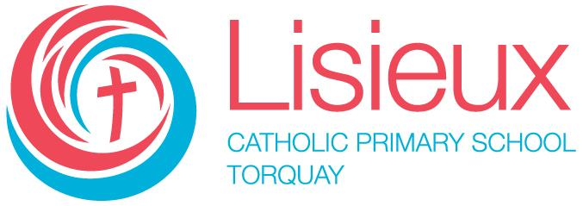
Lisieux Catholic Primary School
Assessment and Reporting Procedures

Lisieux Catholic Primary School is a school which operates with the consent of the Catholic Archbishop of Melbourne and is owned, operated and governed by Melbourne Archdiocese Catholic Schools Ltd (MACS).
This section sets out the steps that are taken at Lisieux to adhere to the rules of the policy and achieve the policy purpose.
- Methods used to assess student learning progress and achievement
  - Formative assessment
  - Summative assessment
  - Students with additional learning needs
- Process for developing assessment tasks
- Cycle of review of assessment practices and processes
  - Student data
  - Identification of data
  - Collection of data – cycle, methods, storage, dissemination
  - Analysis of data
  - Interpretation of data
  - Use of data to inform teaching and assessment practices
- Reporting practices
  - Formative assessment
  - Summative assessment
  - Written reports
  - Student/teacher/parent conferences
  - Students with additional learning needs
  - Students with additional needs
- Personalised Learning Plans
  - NCCD data
  - Participation in national testing programs such as NAPLAN, PISA

